EXPERIMENT NO. 10
INVESTIGATION OF COEFFICIENT AND PRODUCT QUANTIZATION NOISE AND LIMIT-CYCLE OSCILLATIONS USING MATLAB
Name | Lokesh A
Register Number | 192512293
Programme | B.E. Electronics and Communication Engineering (ECE)
Experiment Date | 12/10/2026
AIM
To investigate coefficient quantization noise, product quantization noise, zero-input limit-cycle oscillations, and overflow/saturation effects in an IIR digital filter using MATLAB.
SOFTWARE REQUIRED
MATLAB with the Signal Processing Toolbox.
THEORY
Finite word-length effects occur when digital signal-processing values are represented using a limited number of bits. Coefficient quantization changes the filter coefficients and may affect the response and pole locations. Product quantization introduces rounding errors during multiplication and accumulation. Recursive filters may produce nonzero outputs under zero input, a behavior called a limit cycle. Overflow occurs when a value exceeds the representable range; saturation clips the value to the permitted range.
MATLAB PROGRAM
clc; clear; close all;

%% INPUT PARAMETERS
b = [0.0048 0.0193 0.0289 0.0193 0.0048];
a = [1 -2.3695 2.3140 -1.0547 0.1874];
Bc = 8; Bp = 16; N = 200;
x = [1 zeros(1,N-1)];
n = 0:N-1;

%% COEFFICIENT QUANTIZATION
S = 2^(Bc-1)-1;
bq = round(b*S)/S;
aq = round(a*S)/S;
aq = aq/aq(1);

%% IDEAL AND QUANTIZED RESPONSE
y_ideal = filter(b,a,x);
y_coeff = filter(bq,aq,x);
e_coeff = y_ideal-y_coeff;
MaxCoeffError = max(abs(e_coeff));
SQNR_coeff = 10*log10(sum(y_ideal.^2)/sum(e_coeff.^2));

%% PRODUCT QUANTIZATION
Sp = 2^(Bp-1)-1;
y_prod = zeros(1,N);
xstate = zeros(1,length(b));
ystate = zeros(1,length(a)-1);
for k = 1:N
xstate = [x(k), xstate(1:end-1)];
feedforward = round((bq.*xstate)*Sp)/Sp;
feedback = round((-aq(2:end).*ystate)*Sp)/Sp;
accumulator = sum(feedforward)+sum(feedback);
y_prod(k) = round(accumulator*Sp)/Sp;
ystate = [y_prod(k), ystate(1:end-1)];
end
e_prod = y_coeff-y_prod;
MaxProdError = max(abs(e_prod));
SQNR_prod = 10*log10(sum(y_coeff.^2)/sum(e_prod.^2));

%% ZERO-INPUT LIMIT-CYCLE TEST
y_zero = zeros(1,N);
state = [0.01 0.01 0.01 0.01];
for k = 1:N
products = round((-aq(2:end).*state)*Sp)/Sp;
y_zero(k) = round(sum(products)*Sp)/Sp;
state = [y_zero(k), state(1:end-1)];
end
LimitAmplitude = max(abs(y_zero));
LimitSamples = find(abs(y_zero)>1e-12);

%% OVERFLOW AND SATURATION
xo = 1.2*ones(1,N);
y_over = filter(bq,aq,xo);
y_sat = min(max(y_over,-1),1);
OverflowCount = sum(abs(y_over)>1);
MaxOverflow = max(abs(y_over));

%% DISPLAY RESULTS
fprintf('\\n--- QUANTIZATION RESULTS ---\\n');
fprintf('Maximum coefficient response error = %.6e\\n',MaxCoeffError);
fprintf('Coefficient SQNR = %.2f dB\\n',SQNR_coeff);
fprintf('Maximum product quantization error = %.6e\\n',MaxProdError);
fprintf('Product SQNR = %.2f dB\\n',SQNR_prod);
fprintf('Zero-input maximum amplitude = %.6e\\n',LimitAmplitude);
fprintf('Nonzero limit-cycle samples = %d\\n',length(LimitSamples));
fprintf('Overflow samples = %d\\n',OverflowCount);
fprintf('Maximum output magnitude = %.6f\\n',MaxOverflow);

Test = {'Coefficient Quantization';'Product Quantization';'Zero-Input Test';'Overflow Test'};
MaximumValue = [MaxCoeffError;MaxProdError;LimitAmplitude;MaxOverflow];
SQNR_dB = [SQNR_coeff;SQNR_prod;NaN;NaN];
disp(table(Test,MaximumValue,SQNR_dB));

disp('Original numerator coefficients:'); disp(b);
disp('Quantized numerator coefficients:'); disp(bq);
disp('Original denominator coefficients:'); disp(a);
disp('Quantized denominator coefficients:'); disp(aq);

%% FIGURE 1
figure; stem(n,y_ideal,'b','filled'); hold on; stem(n,y_coeff,'r--');
grid on; xlabel('Sample n'); ylabel('Amplitude');
title('Ideal vs Coefficient-Quantized Response'); legend('Ideal','Quantized');

%% FIGURE 2
figure; plot(n,e_coeff,'LineWidth',1.2); grid on;
xlabel('Sample n'); ylabel('Error'); title('Coefficient Quantization Noise');

%% FIGURE 3
figure; stem(n,e_prod,'filled'); grid on;
xlabel('Sample n'); ylabel('Error'); title('Product Quantization Noise');

%% FIGURE 4
figure; plot(n,y_zero,'LineWidth',1.2); grid on;
xlabel('Sample n'); ylabel('Amplitude'); title('Zero-Input Limit-Cycle Test');

%% FIGURE 5
figure; plot(n,y_over,'b','LineWidth',1.2); hold on; plot(n,y_sat,'r--','LineWidth',1.2);
grid on; xlabel('Sample n'); ylabel('Amplitude');
title('Overflow and Saturation Test'); legend('Without Saturation','With Saturation');

%% FIGURE 6 AND FIGURE 7
figure; zplane(b,a); grid on; title('Ideal Filter Pole-Zero Plot');
figure; zplane(bq,aq); grid on; title('Quantized Filter Pole-Zero Plot');

fprintf('\\nFinite word-length effects were investigated using MATLAB.\\n');
OUTPUT / OBSERVATIONS
The experiment produces seven figures: ideal versus coefficient-quantized response, coefficient quantization noise, product quantization noise, zero-input limit-cycle test, overflow and saturation test, and ideal and quantized pole-zero plots. The supplied MATLAB screenshots are included below as output evidence.
MATLAB OUTPUT FIGURES
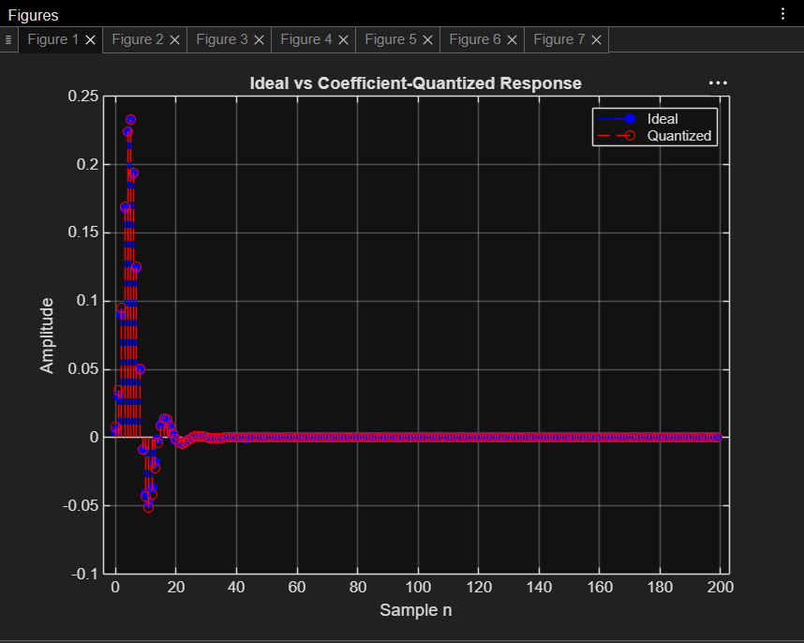
Figure 1. Ideal vs coefficient-quantized response
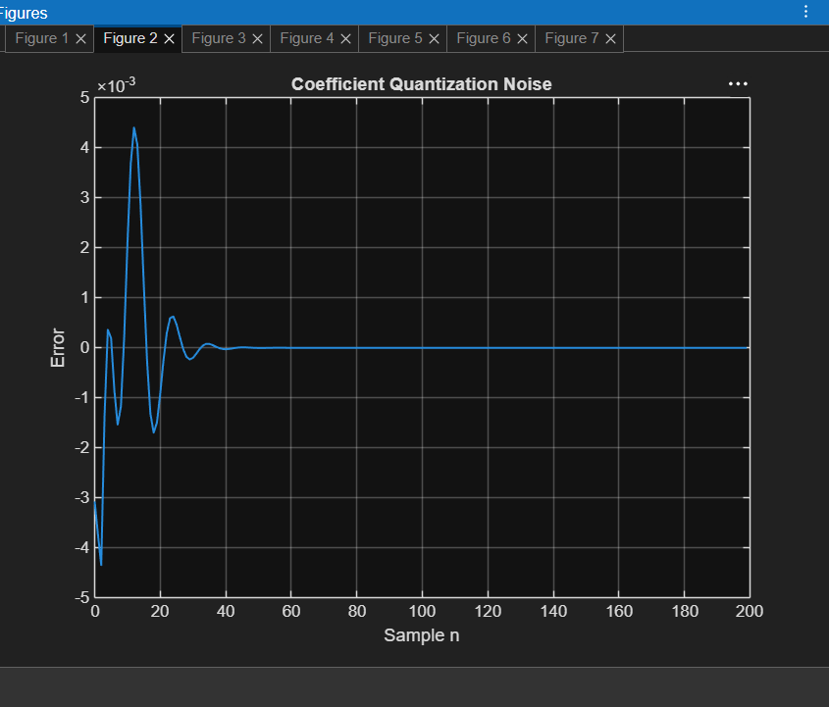
Figure 2. Coefficient quantization noise
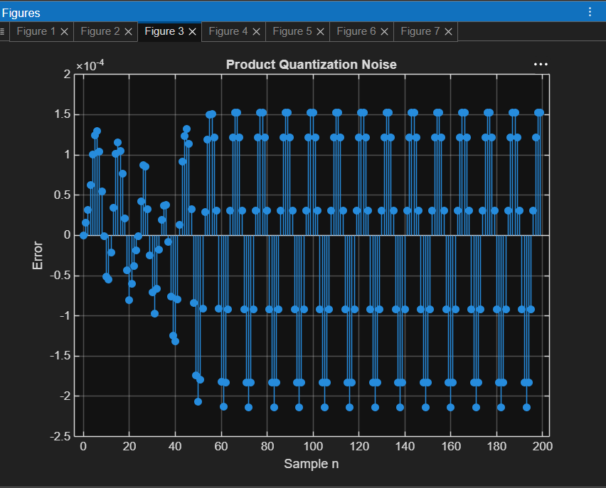
Figure 3. Product quantization noise
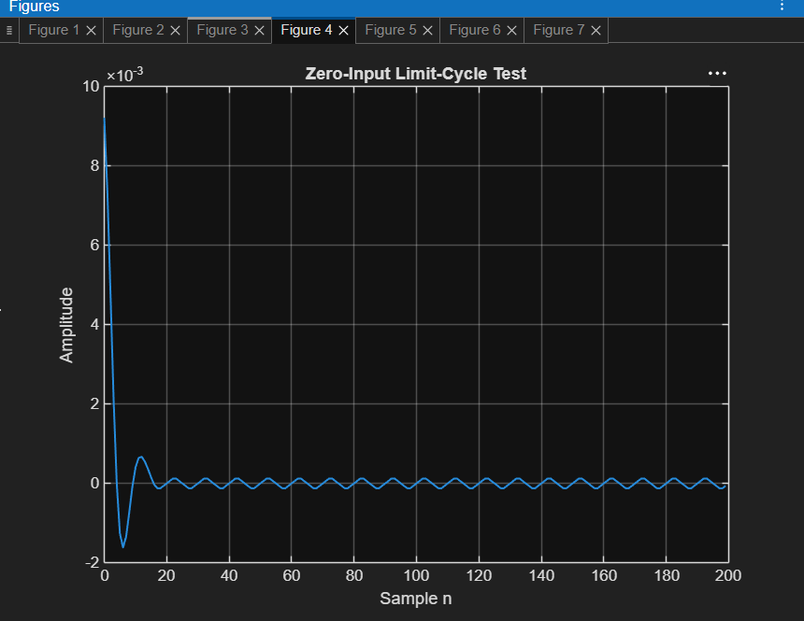
Figure 4. Zero-input limit-cycle test
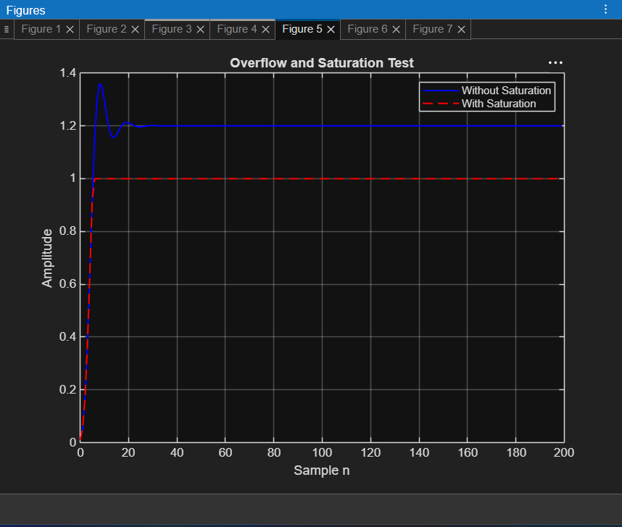
Figure 5. Overflow and saturation test
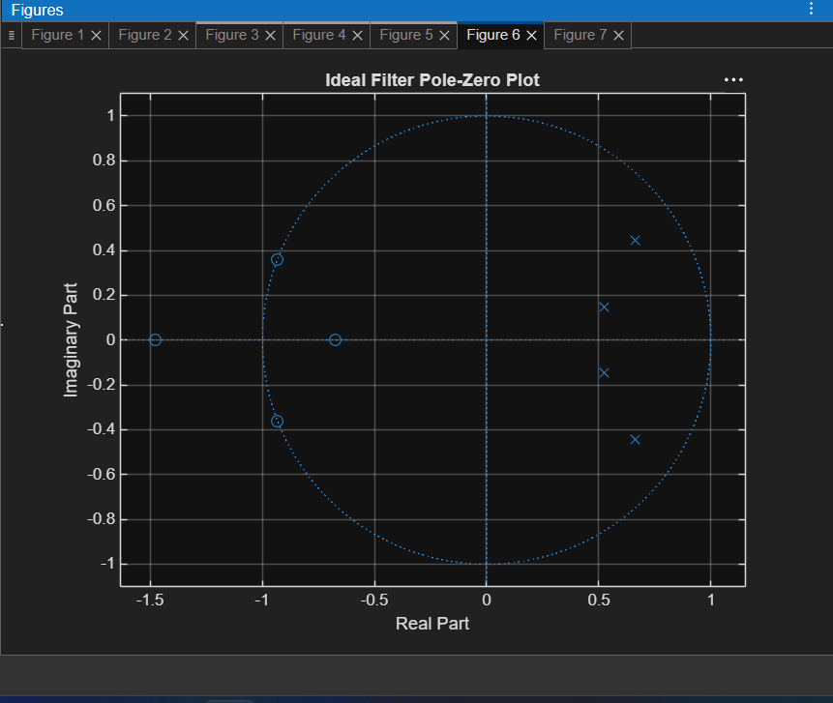
Figure 6. Ideal filter pole-zero plot
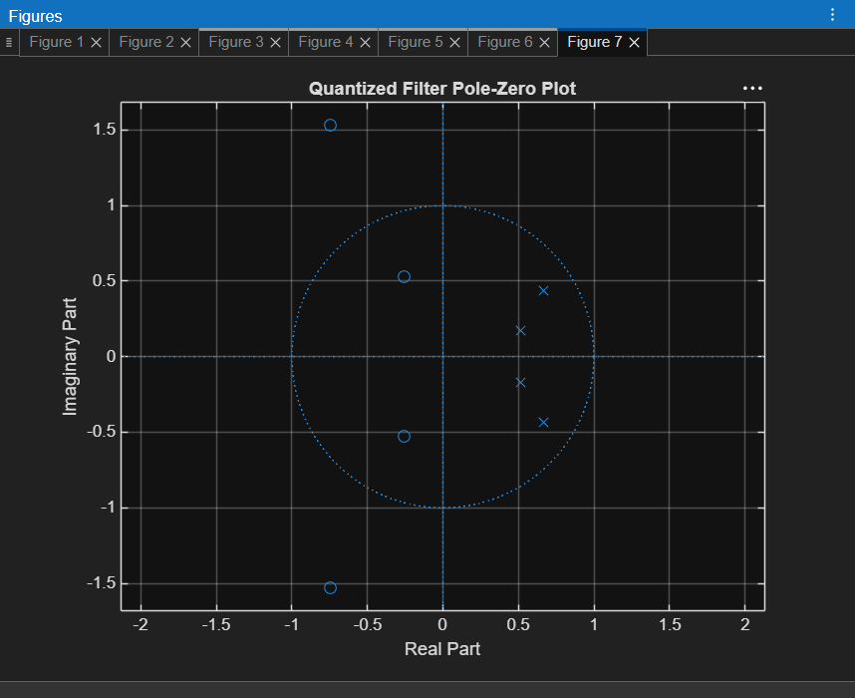
Figure 7. Quantized filter pole-zero plot
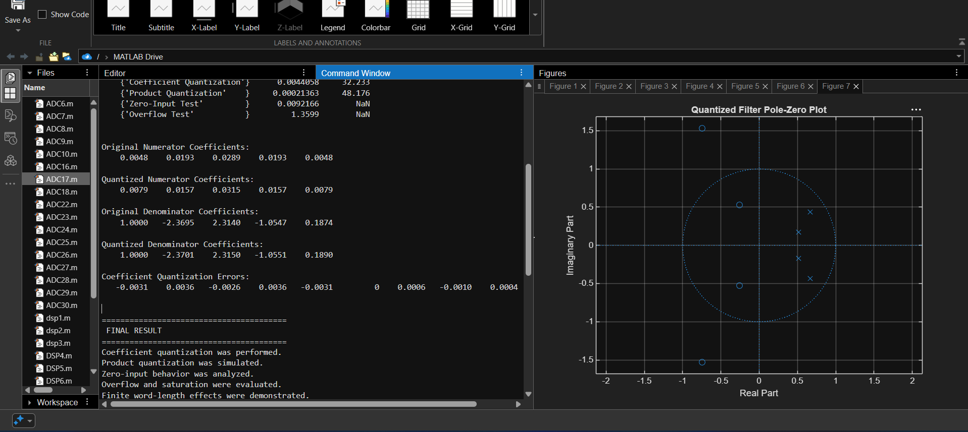
MATLAB Command Window output and coefficient values
RESULT
Coefficient and product quantization effects in an IIR filter were investigated using MATLAB. The experiment also examined zero-input limit-cycle behavior and overflow/saturation. The output figures demonstrate the effects of finite-precision arithmetic on the filter response.

